April 21st, 2016

**FREE**

**Minburn Moments**

## Slow Cooker Hawaiian Sticky Chicken

2 pounds boneless, skinless chicken breasts

3 cups chicken broth

1 cup pineapple juice

1 cup crushed pineapple

3 cloves garlic

1 teaspoon salt

1/2 cup apricot jam

1/4 cup soy sauce

2 tablespoons teriyaki sauce

1/4 cup hoisin

1/4 teaspoon crushed red pepper flakes

1 tablespoon Wondra® flour

hot cooked rice

4 chopped scallions for garnish

sesame seeds for garnish

### Directions:

1. Place the chicken breasts, chicken broth, pineapple juice, crushed pineapple, garlic cloves and salt in your slow cooker and set on high.
2. Cook for 4 hours then remove the chicken to a cutting board.
3. Drain the broth from the slow cooker into a large measuring cup or bowl. Measure out 2 cups of the broth (including some of the crushed pineapple) and put back into the slow cooker.
4. Add the apricot jam, soy sauce, teriyaki sauce, hoisin, crushed red pepper flakes and Wondra® flour to the broth and whisk to combine.
5. Shred the chicken with two forks and return to the slow cooker with the sauce. Stir to combine the chicken with the sauce, cover and cook on high for 1 more hour.
6. Serve over hot, cooked rice, and garnish with chopped scallions and sesame seeds.

Community

Calendar

**April**

**23rd**-Family Coloring Party. @ Minburn Legion Hall 6:30pm

**26th**-Story Time

1:00-2:00pm

@ the library

**28th**- Kids Craft Night- 6pm @ the Library- Trying something new!

May

**3rd-** Story Time

1:00-2:00pm

@ the library

**7th-** KidsFest

10:00am-Noon

Dallas Co Fairgrounds

**10th-** Story Time

1:00-2:00pm

@ the library

**13th-** **SUMMER READING PROGRAM**

**KICK OFF!**

**Meek Park 6pm**

**17th**- Story Time

1:00-2:00pm

@ the library

Summer Reading Program Activity

6:00-7:00pm

@ the Legion Hall

**24th**- Story Time

1:00-2:00pm

@ the library

**26th**- Summer Reading Program Activity 6:00-7:00pm

@ Legion Hall

Formerly the Pinhook Page

ADM Schools commencement ceremonies will be: Sunday, May 29th at 2:30pm at the High School Gym.

The Minburn 4th of July Committee is looking for any kind of vendors for this year’s celebration! Food, Craft, In home business... Please contact Nicole at the Minburn Library or City Hall if interested

515-677-2712 or 515-677-2245

**Looking for volunteers!**

**Saturday, April 30th! 10am**

Dee Petrak received funds through Thrivent Financial on Minburn's behalf for Minburn's Beautification! The funds will be used to replace some rotten barrels downtown and fill them all up with new flowers! Grandma Marie's Greenhouse in Linden is donating matching funds to help with the purchase of all the things we will need to complete this project! Thank you Dee, Thrivent, and Grandma Marie's Greenhouse for helping us spruce up Minburn! Come down to the library that morning or call Nicole at 677-2712

**FOR LEASE**

Cafe portion of historic Minburn Depot on the RRVT trail.

**NOW AVAILABLE!**

Commercial appliances included. Tenant provides tables, chairs, cooking/eating utensils, etc.

**Contact Minburn City Hall**

**for more info 677-2245**

Minburn Scramble Answers

Depot

Bicycle

River

Betterment

Legion

Community

Methodist

Washington

Church

Storytime

Bookclub

Best Place to Live in Iowa

# Farm Fresh Eggs for Sale!

$3/Dozen Call Joyce

515-677-2264

July 4th Theme:

Star Wars, "May the 4th be with You!"

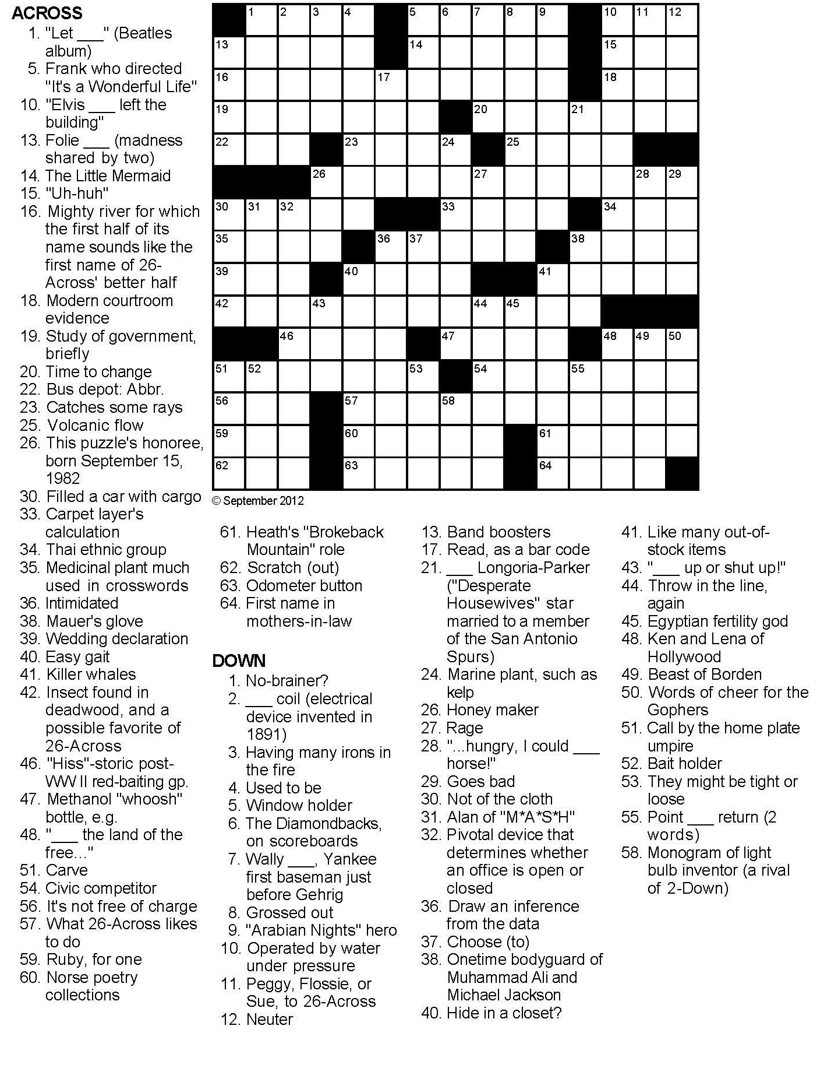

# Have something to announce or advertise? How about something to sell? Put it on the Minburn Moments page! Contact Nicole at The Minburn Library call

# 515-677-2712 , email minburnlib@minburncomm.net, or stop by I would be glad to add it in the next issue. Currently

# bi-weekly production.

Area Churches

**United Methodist**

**Church**

Wednesday Club

Wednesday's

5:30-7:15pm

Church Service 11am

**Washington Chapel Church of Christ**

Sunday School 9:30am

Church 10:30am



**New Story Time!**

**Starting April 5th Minburn Public Library will have a**

**children's story time from**

**1:00-2:00 every Tuesday afternoon. Come read a story with me and have some time to check out books!**

Reading

Rules

We are collecting toilet paper and paper towel rolls for a Summer Reading Program craft. If anyone has some they would like to donate bring them to the library anytime! Thank you!

Minburn Public Library is looking for a few volunteers to help with this years Summer Reading Program! There are several areas of need...help with registration on May 13th, snack donations for all the programs, any crafting supplies anyone would like to get rid of, buttons, ribbon, rubberbands, tissue paper...Contact Nicole at the Library if you would like to help out. minburnlib@minburncomm.net, or 515-677-2712

**ADM's last day of school is**

**JUNE 3rd 1:00 dismissal**

New Computers!

Thank you to the Bock Family Foundation for the generous grant we received that together with a donation from 'Bits of Technology' Computer Store in Perry, we are able to finish upgrading our computers to newer, faster machines! Thank YOU!

We are trying something new! The 4th Thursday of the month will be

KIDS CRAFT CLUB!

We will have a fun craft for kids to do. It will be an hour of fun!

6:00pm-7:00pm

**Early Out's**

Wednesday, May 4th

Movie @ Legion Hall

Tuesday, May 17th 6-7pm

Nature Craft-Summer Reading Program

Thursday, May 26th 6-7pm

Outdoor Activity-Summer Reading Program

**THANK YOU!**

A HUGE Thank You goes out to H.B Worley for his large donation of outdoor equipment and toys for the library patrons to enjoy! The children will get much use out of these things during Gym Time and Summer Reading Program. Thank You H.B!

Summer Reading is just around the corner **On Your Mark, Get Set...READ!**

All ages are welcome and we have planned activities from May 13th through August 6th!

Craft Club

May 12th

6:30pm @ library

**Kids Craft club**

April 28th

6:00pm @ Library

Complete the craft provided or bring your own project

GYm Time

Every

friday

10am-Noon

MInburn Elementary Gym

**Book Club**

**'Glass Castle'**

**By: Jeannette Walls**

**Discussion**

**May 17th**

**11:00am**

**@ the Library**

**Library hours**

Monday -12-5:30pm

Tuesday - 12-5:30pm

Wednesday - Closed

Thursday - 12-5:30pm

Friday - 12-6pm

Gym time Fridays

10am-noon

MInburn Elementary GYm

Minburn Public Library's

Summer Reading Kick Off

will be

**May, 13th at 6:00pm**

**at Meek Park Skating Rink**

MIKE OZ THE MAGICIAN

will be performing

Hot Dogs, chips, and a dessert will be provided!

**On Your Mark, Get Set**

**READ!**

**Registration will start May 13th and go through June 2nd**

Library NewS!

